June 1-5 Art Lesson All Grades Drawing a Horizone Line
Today we are drawing Sandcastles but I am looking to see that you have drawn a horizon line . A horizon line iss the place where the skiy and the land meets in a picture and it gives our artwork depth. Below are step by step instructions for you to follow to draw your sandcast. Feel free to add more once you have your castel drawn. 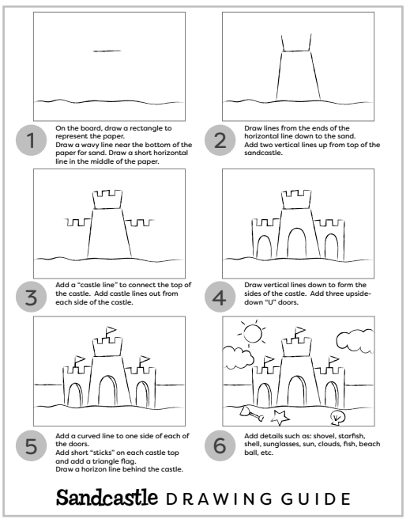
Please have then write their name and grade on their work and then send me a picture of it to get credit/grade for it at:
desaulniert@springfieldpublicschool.com

